Math Gladiator

By

Raffi Kudlac & Bryce Paterson

1. Overview

The goal of our game is to teach basic mathematical skills to our users who we intend to age anywhere from 4 to about 13. We hope to accomplish this through a series of interactive levels where users will participate in a turn based combat with the computer. Answering correct math questions in shorter amounts of time will result in higher damage to the opponent. We anticipate that our audience will find this style of answering math questions engaging.

2. Game Screenshots

2.1. Splash Screen

Below is a image of our current splash screen. It’s purpose is to simply introduce the name of the game and promote excitement for 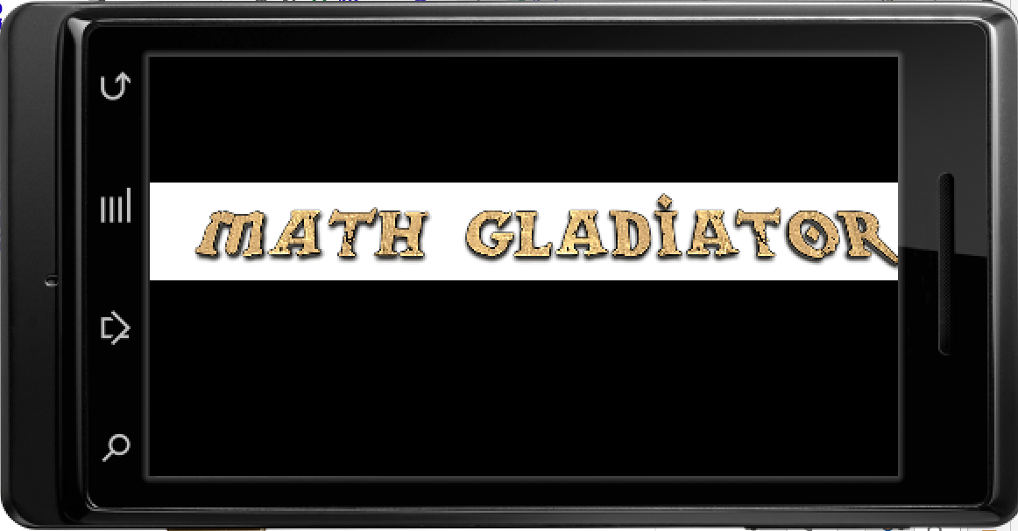the upcoming events.

(figure 1)

2.2. Menu Screen

Below is an image of our games main menu page, from here, users will be able to access all features of the game. All pieces of text are pretty self explanatory, all the user has to do to is 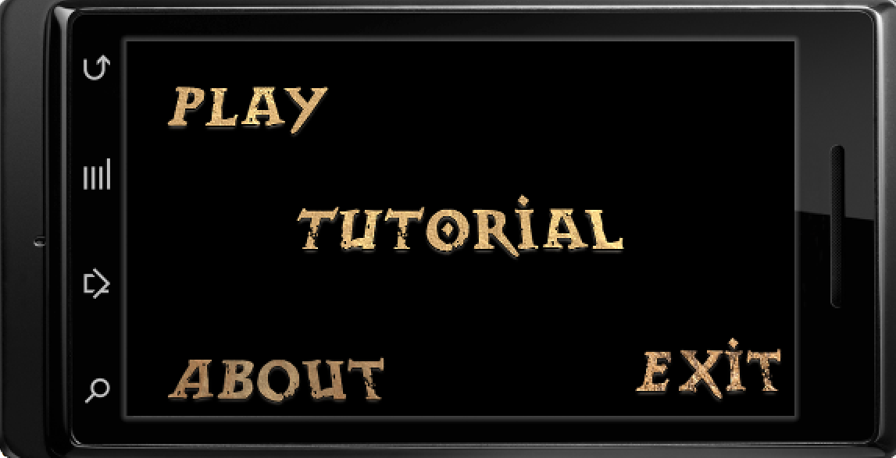select one to pursue that option.

(figure 2)

2.3. Credits Screen

Below is an image of our credits page. Here is where the users will go to see information about the game, who it was made by and any sources that need acknowledgement for their contributions to the game.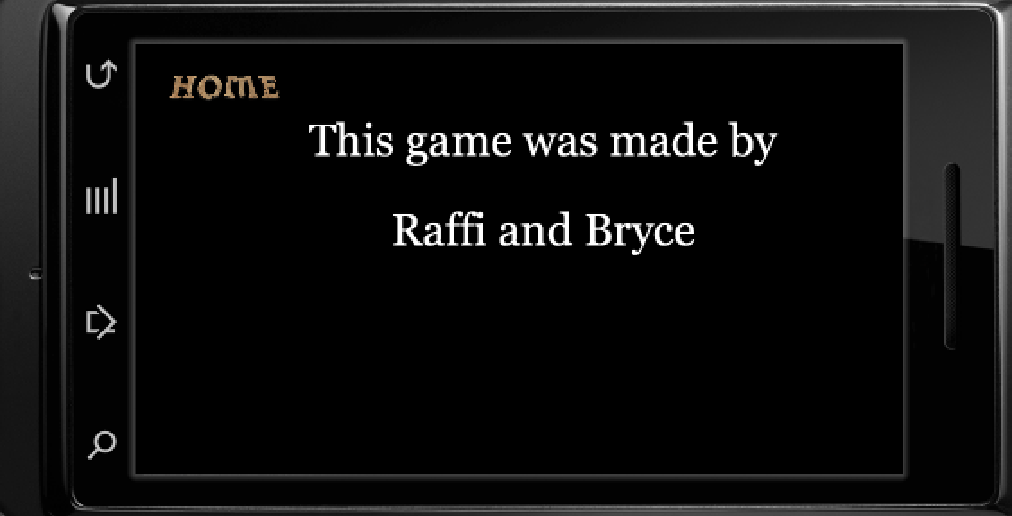

(figure 3)

2.4. Tutorial Screen

Our tutorial screen currently covers a very basic overview of our game . Explaining the users objectives, informing them how to reach them and 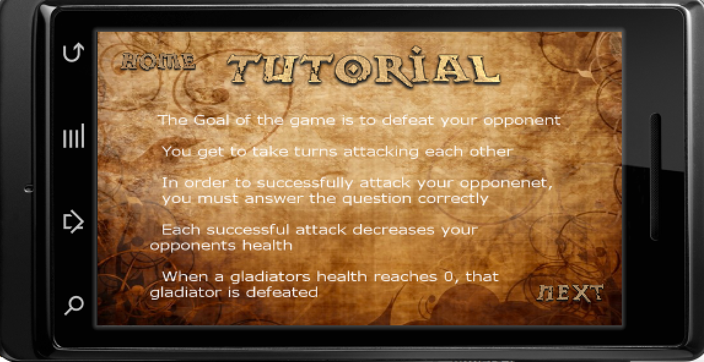the simple layout of the game.

(figure 4)

2.5. Consent Screen

Upon the users first use of the app the user is asked permission if we can record their experience of our app and learn from it. The Users response is saved to a text file and the file is read 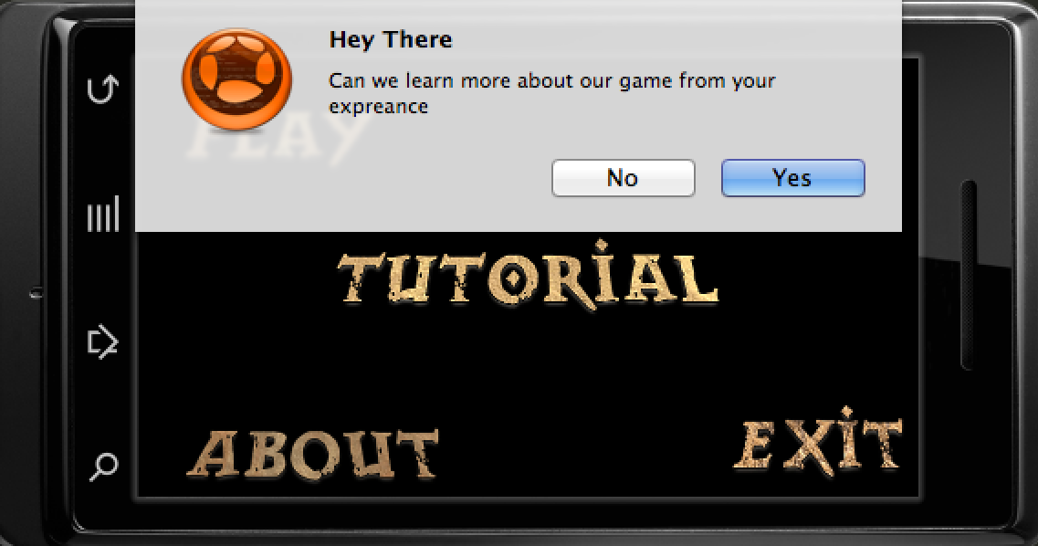every time the app is opened.

(figure 5)

2.6. Level Screen

Here is the level screen where the user can pick what kind of math questions he/she would like to face and of what difficulty. Right now users can only select addition. Users will also initially have to defeat one level to unlock the next. For testing purposes, all the 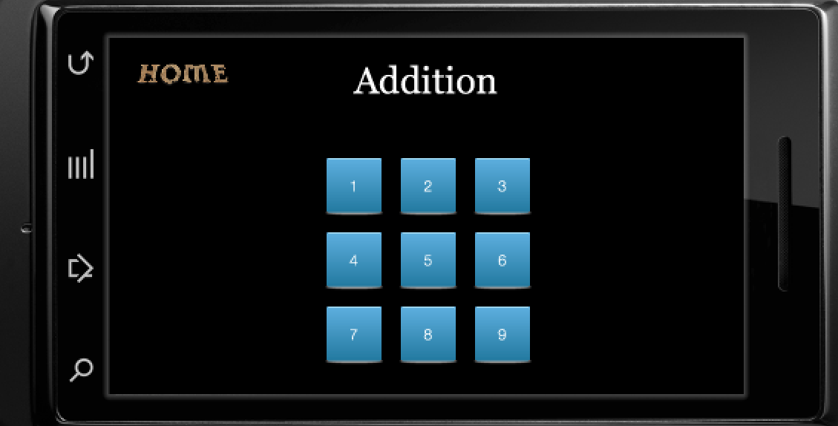levels in the screen shot are unlocked.

(figure 6)

2.3. Game Play Screen

Below is the game play screen at its basic level with no physical image to represent the player and the computer, they are merely represented by the fractions in the top left and right corners. Computer in the left and player in the right (see figure 7). Questions appear at the top of the screen and the user enters the answer in the calculator. If the answer is correct then damage is dealt to the computer (see figure 8). If the answer is 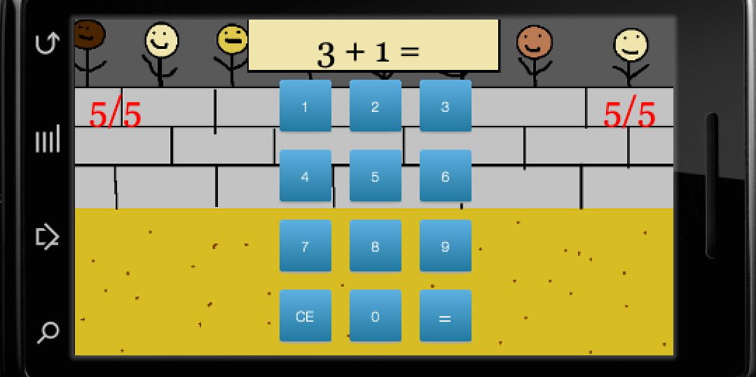

(figure 7)

incorrect then no damage is done. After each players turn the computer takes a turn as well. The capability of the computer getting a problem right is calculated through probability. The higher level the user is at the higher chance the

(figure 8)

computer will do damage. Figure 9 shows a case where the computer has had two successful attacks.

(figure 9)

3. Intellectual Property

All current images in Math Gladia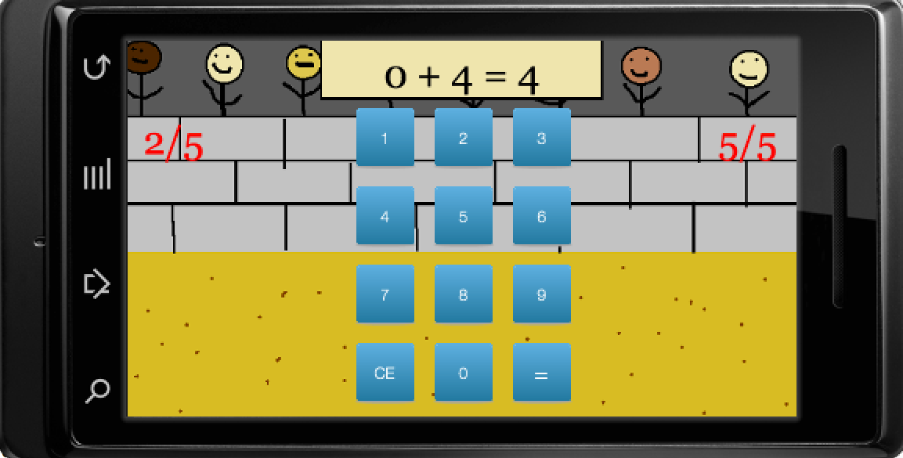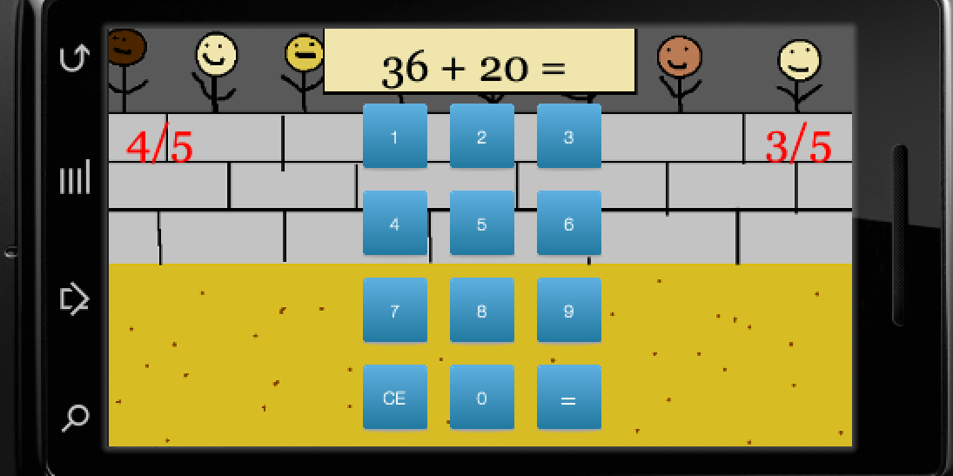tor were created by the authors except for the blue box images in the level screen which were taken from

http://www.iconarchive.com/show/pretty-office-9-icons-by-custom-icon-design/square-icon.html